36 APPRECIATION LETTERS TO JACQUES CORY

1-7. 7 Appreciation letters by Professor Ilan Meshoulam, head of Business Administration School University of Haifa, Gad Propper, co-owner of Osem Industries, Joshua Sobol, world-wide famous playwright, Itamar Levin, leading journalist and editor, Arieh Avneri, Chairman of Ometz Anti-corruption organization, David Golan, CEO of leading Israeli companies, Professor Yehuda Kahane, head of the Akirov Institute for Business and Environment, Tel Aviv University. The Appreciation letters were written for Jacques Cory's 2010 Emet Prize candidacy, Israeli "Nobel". The letters are in Hebrew, and were translated into English.

Appreciation Letters by Ilan Meshoulam, Gad Propper, Joshua Sobol, Itamar Levin, Arieh Avneri, David Golan, Yehuda Kahane, En. & Heb, for the 2010 Emet Prize candidacy, Israeli 'Nobel' (herebelow photos of Arieh Avneri – left and Joshua Sobol – right).

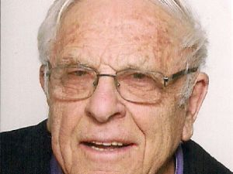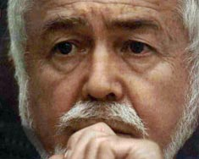

8. Appreciation Letter by Onn Winckler, Head of the Department of Multidisciplinary Studies, University of Haifa, March 15, 2005

9. Appreciation Letter by Arnon Gat, CEO of the US semiconductor equipment Company AG Assoc., on establishing a subsidiary in Israel and finding a strategic partner, writing a business plan, obtaining approved enterprise status, R&D grants and other incentives, with efficiency, integrity, creativity, independence & motivation– 1.22.1993

10. Appreciation Letter by Reuben Baron, Chairman of the Consortium of Earth Stations for Satellite Communications, comprising Rafael/Galram, Israel Aircraft Industries, Elisra, Gilat and the Technion, on the successful establishment and management of the Consortium by Jacques Cory during two years, with initiative, independence, skill in negotiations, receiving the best conditions and running the Consortium smoothly albeit the contradictory interests, preparing a business plan and convincing the authorities on the viability of the plan, devotion, motivation and integrity- 5. 15, 1994.

11. Appreciation Letter by Shuki Schwartz, CEO of Finish, on 4/20/1995, on managing negotiations on the Joint Venture with HON, a billion dollar office furniture conpany, stating outstanding negotiations skills and concluding the deal expeditiously

12. Appreciation Letter in Hebrew by Adv. Nati Shilo (Legal Counsel of the American MRV), on M&A, August 5, 1995

13. Appreciation Letter in Hebrew by Uri Levit, CEO of Poalim Investments, on M&A – January 17, 1993

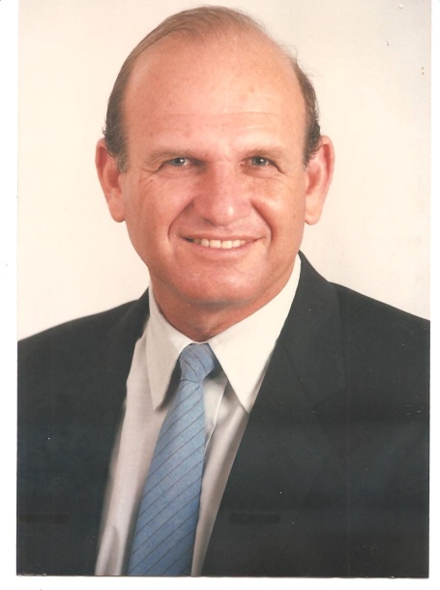

14. Certificate of Best Lecturer at the University of Haifa in 2005 signed by Rector & Students' Chair

15. Appreciation Letter by Top Executives Electric Comp. who Studied 3 Courses of 160 hours in 2005-2007

16. Award of the highest Israeli ethical award "Itur Hamofet" in 2015 by Ometz, the leading Israeli anti-corruption organization (citizens for ethical administration and social and legal justice). The co-recipient of "Itur Hamofet" was Benny Gantz, former Chief of General Staff of the Israeli Defense Forces, and the 2020 Alternate Prime Minister and Minister of Defense.

Award Ethical Prize/ List of recipients of awards & link to Jury reasoning for the award.
Ytube/ - Clip on Cory's receiving the award.
Cory/ - Jury's reasoning for the award received by Cory.
Film1'16 – Video of the one and a quarter hour's ceremony.

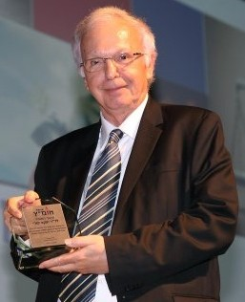
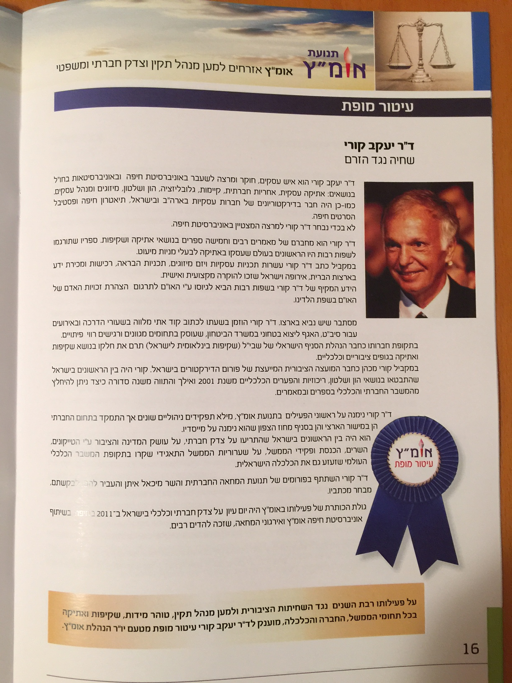

17. Appreciation Letters by BA Students at the University of Haifa - 2005 (Feedback of Students in 2005 - 5.0, 4.98, 4.95 out of 5.0)

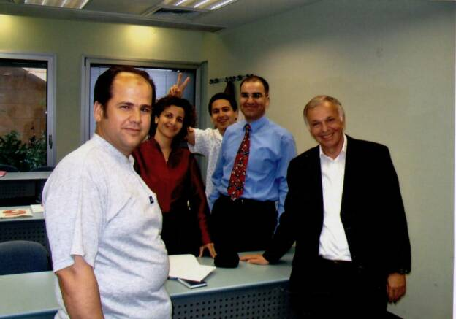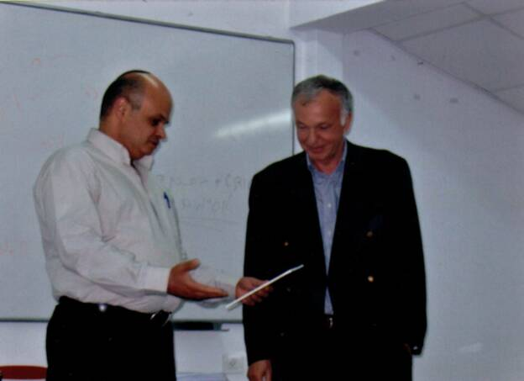

18. 4 Appreciation Letters by the University of Haifa's Students

19. Appreciation Letters by Students of Course on Business Ethics & Future of Capitalism in 11/2010 and in 11/2015

20. Appreciation Letter by Israel's former President Efraim Katzir on Cory's activities, July 5, 1989

21. Appreciation Letter by former CEO of Discount Bank Harry Recanati (in French) to Cory, 9.11.2001

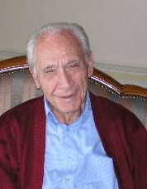

22. Appreciation Letter by Cory's employees at the Elbit's Finance & Sales Department: June 5, 80

23. Appreciation Letters by Elbit's CEO - April 1987 & August 1987

24. Appreciation Letter by General Shmaya Avieli, the general manager of Sibat, the International Defense Cooperation Directorate of the Israel Ministry of Defense – 4/2014.

Appreciation.

Photo of the ceremony of the signature of Sibat's Ethical Code, written by Cory in 2014. Signing is Avieli, extreme left is his deputy, extreme right is Cory and near him is Shahar Horev, responsible for ethics at Sibat. Present at the ceremony are part of Sibat's managers.

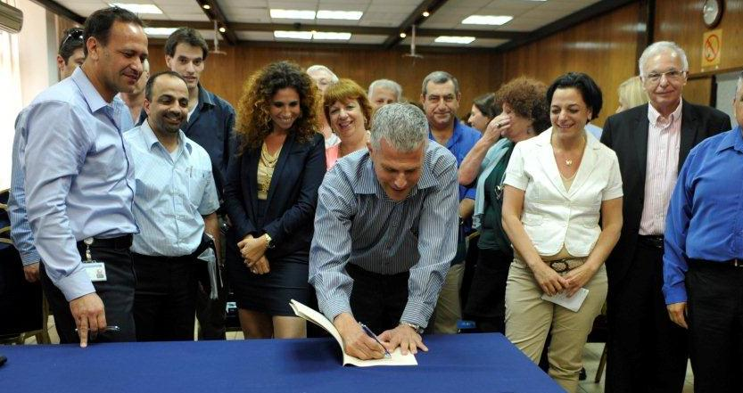

25. Appreciation letter on Cory's initiative, editing & partly translating with Ladinokomunita of the UN Declaration of Human Rights into Ladino – 2011.

Initiated ... - Correspondence of Cory with the UN.
& Participated in Translation & Editing of UN Universal Declaration of Human Rights into Ladino with Ladinokomunita 2011, - Translation into Ladino from the UN website.
eSefarad Spain – Appreciation letter to Jacques Cory published in Ladino by eSefarad Spain.

26. Letter Spanish Ambassador.. – 23.6.2011 – Appreciation letter by Alvare Iranzo, the Spanish Ambassador to Israel, on Cory's discovery of the Coria's synagogue.

Links to some of the dozens articles, written by Jacques Cory in Spanish, Ladino, French, English and Hebrew, and published all over the world by important journals, and afterword.

How I discovered the synagogue of Coria: in Tarbut Sefarad Spain Spanish... Aurora Israel Sp... Anajnu Chile Sp.. Shelanu Argentina Sp.. CCIU Uruguay Sp eSefarad Ladino & Sp.. Ladinokomunita.. Forojudio Mexico Lad.. Los Muestros Belgium Lad.. Aki Yerushalaim Lad.. Sephardic Horizons Lad... News1 Hebrew.. Sharsheret Hadorot English.. Heb.. Halapid US En.. Nahar Misraim France French TOC.. Text.. Letter Spanish Ambassador.. Afterword

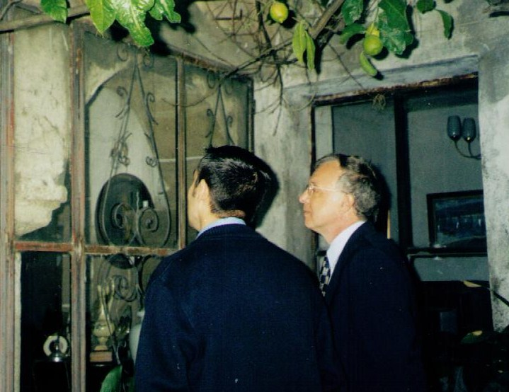

27. Appreciation Letter by the EU-Israel Forum (on Cory's lecture in Stresa, Italy in 2001)

Similar appreciation letters were received for participating in many other forums.

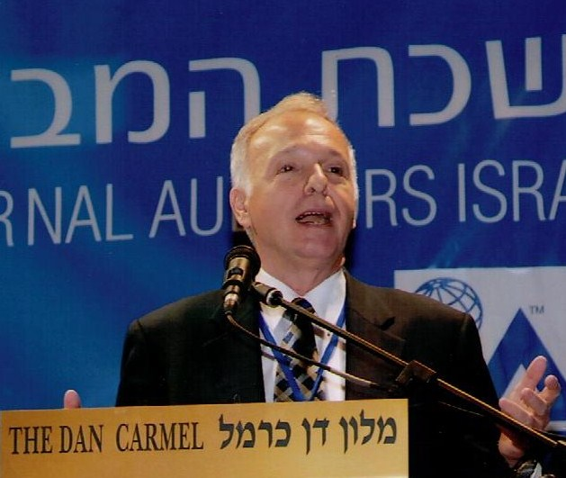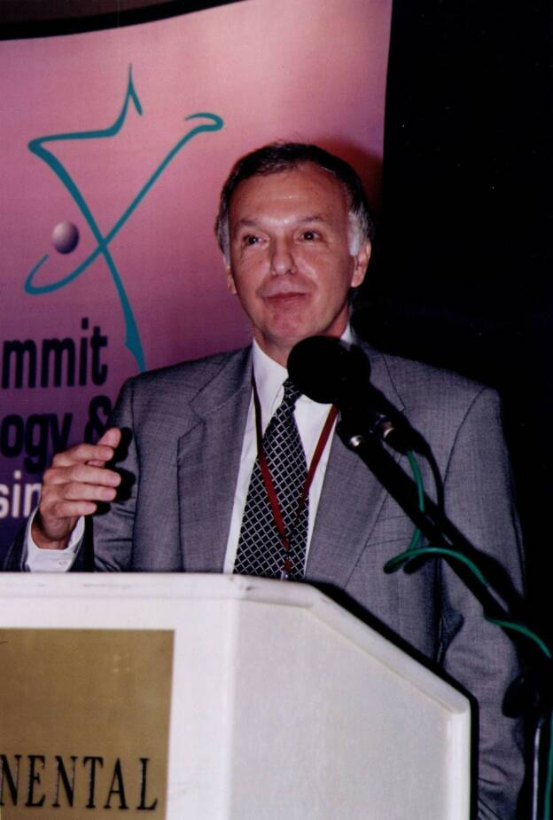

28. Appreciation Letter by Distinguished Professor Dan Shechtman, Nobel Prize in Chemistry (2011) (on Cory's lecture at the Technion)

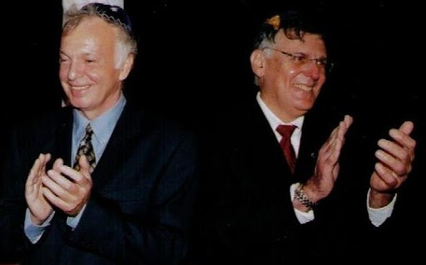

29. Evaluation of "The Future of Capitalism" Courses at MBA Programs of the Tel Aviv University & the Technion, 2010

30. International MBA in English at the University of Haifa – Feedback of Students on Cory's Courses in 2004...in 2005

31. The most cherished appreciation – greetings by the family on Cory's 70th & 71st birthday.

Clip on Jacques Cory's 70th Birthday: Presentation,

Greetings

71st Birthday- J. Cory

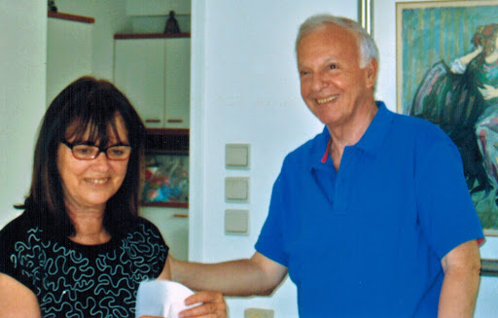

32. Greetings on Jacques Cory's 75th birthday.

J. Cory's 75th Bir.

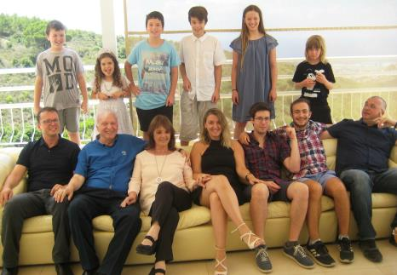

33. Appreciation award on Elbit's Wall Street IPO management by Jacques Cory in 6/1987.

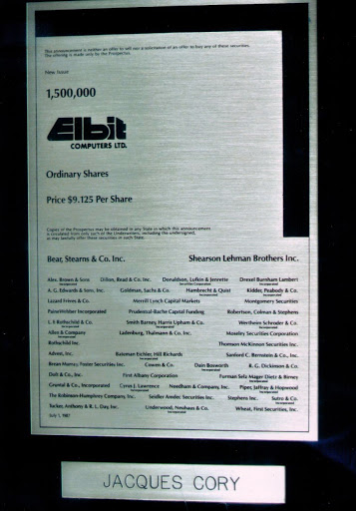
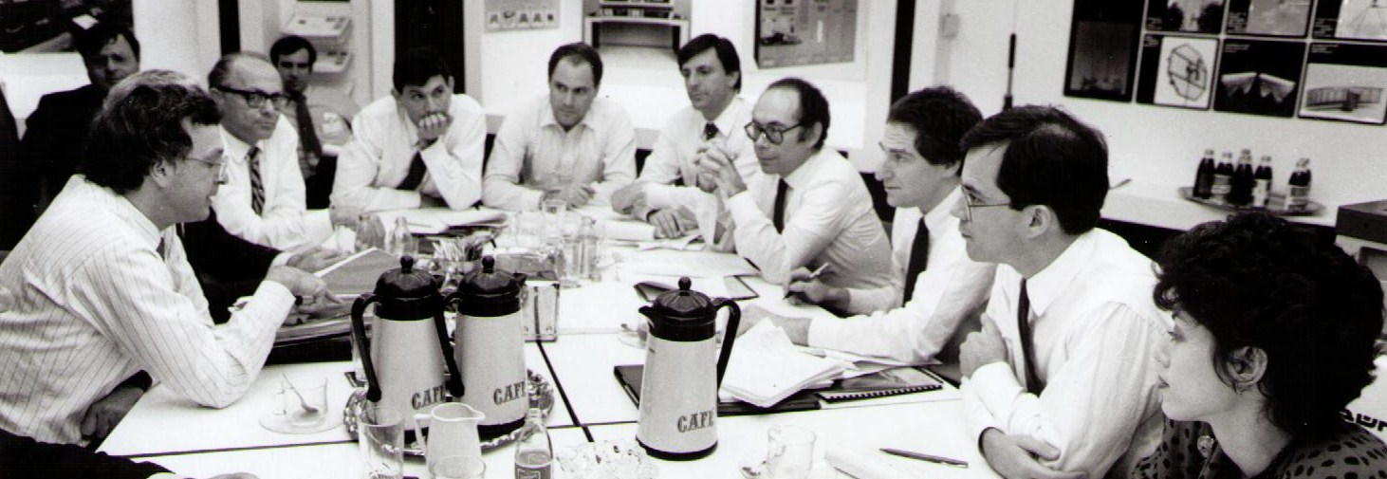

34. Appreciation letter in Ladino on being keynote speaker in Ladino on June 27, 2012.

Keynote Speaker in Ladino on June 27, 2012: on translation of the UN Declaration of Human Rights, discovery of Coria's (Spain) Synagogue

35. Appreciation comments, letters and reports by Jury members of Jacques Cory's soutenance de these on March 23, 2004 at CNAM, Paris, France. Cory was awarded a PhD with distinction for his 2004 dissertation in French based on his two 2001 books in English.

Report of the Jury, CNAM, Paris, March 23, 2004, in French, - by all the Jury members.

Article in Dutch & Review by Henk Van Luijk, Jury Member – in English, French, Dutch.

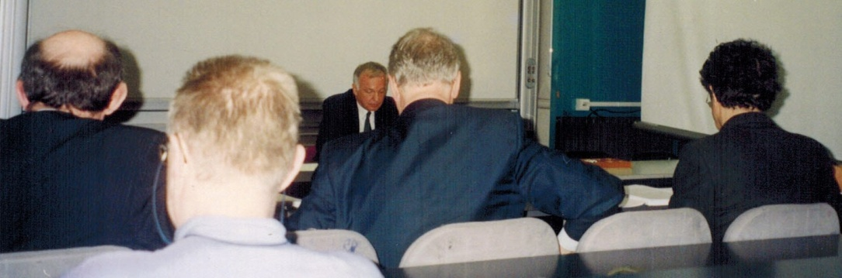
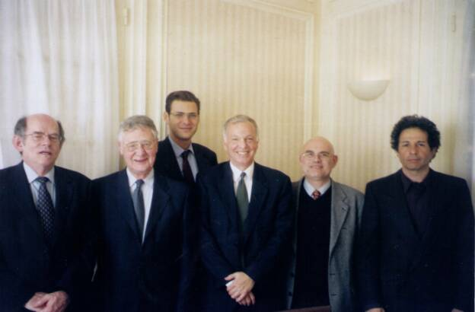

36. Appreciation letter by Joshua Sobol on Jacques Cory's play "Nelly's Choice".

Review by the great Israeli playwright Joshua Sobol on the play, in English/French

Nelly's Choice, a Play in Hebrew by Jacques Cory and Amalia Eyal – Summary, Review by Joshua Sobol and List of Musical Numbers, Audio of Music Part 1, Part 2

Many other appreciation letters and reviews were sent to Cory on all his dozens of books.

