Email sent to a widespread mailing list on the financial crisis on March 16, 2020

Soothsayer:

Beware the ides of March.

Julius Caesar:

He is a dreamer; let us leave him: - pass.

(William Shakespeare, Julius Caesar, Act I, Scene II)

**We are now on the ides of March 2020.** There is a subtle difference between a soothsayer, oracle, seer, fortune teller, clairvoyant, diviner, wizard, psychic... and a prophet, as well as between a prophet and a forecaster. I forecasted in my book ["Business Ethics for a Sustainable Society"](http://www.businessethicscory.com/From-the-Economic-Whirl-to-the-New-Sustainable-Society---Pioneering-Methods-in-Business-Ethics.html) published on October 1, 2009 in the US that a Doomsday Depression will occur by 2020 if the unethical practice of the neo liberal capitalistic economy culminating in the 2008 recession will not be substituted by a new credo based on the main principles of the combination of ethics and profitability. As I was then the only one in the world making and publishing such a forecast almost no one believed me and I was perceived by many as a soothsayer, fortune teller, psychic. But I persevered in my forecast and recommendations as written in my book (pages 18-22) and in its cover page (both enclosed), writing [articles](http://www.businessethicscory.com/Articles.html), teaching [courses](http://www.businessethicscory.com/Courses.html), giving [lectures](http://www.businessethicscory.com/Lectures.html) and writing a new [book](http://www.businessethicscory.com/Books.html) in 2017 called ["Capitalism: Crises and Solutions"](http://www.businessethicscory.com/CAPITALISMCRISESANDSOLUTIONSvers2.pdf). Finally, in December 2019, I published an article called [**Doomsday Depression in 2020- Reality or Fantasy**](http://www.businessethicscory.com/newbookdoomsdaydepressionvers1219.docx), when still prominent analysts continued to forecast eternal growth of the stock exchange & economy.

At this turning point I was taken more seriously and some prominent ethicists and professors wrote me: "You are a real prophet. Let us hope that you don't preach in the desert, as the house is burning but we look away. People don't like to listen to those messages because it is always tough to hear the truth. The situation is serious for the future of the prevailing economic system of which you have well analyzed the shortcomings and the defects which lead us to the catastrophe. Don't desist, keep voicing your concern. The depression will come sooner rather than later". Actually, I am not a soothsayer nor a prophet, I only forecasted what every economist should have noticed since 2009 and some of them predicted, only a decade later in 2019 - a slowdown that will occur in 2020 - but probably nobody predicted the scope of the Doomsday Depression as I did continuously from 10/2009 to 12/2019. A couple of months later, on the ides of March, the collapse of the stock exchange occurred but it will be even worse, as happened in the Great Depression and more. The only way to overcome the Doomsday Depression is by adopting the following 36 Principles or similar ones. As it is not too late to found a New Sustainable Society!

36 Principles of Business and Ethics in the Economic World Towards 2020

**We need to discuss and adopt the following 36 principles, which are in fact the foundation of a New Sustainable Society, focusing on ethics, ecology and social responsibility:**

**1. Companies should see profitability as a viability precondition and not as their only reason for existence, as corporations also employ people, sell products, and contribute to society.**

**2. The mantra of maximization of profits should be discarded, as it necessarily causes maximization of risks and wrongdoing of stakeholders: employees, customers, community and the ecology.**

**3. Financial moderation should prevail, with a balanced leverage (not 30:1 as in Lehman Brothers), sufficient equity, low indebtedness, a positive cash flow, integrity of the financial management, even if it is at the expense of maximizing profitability, growth and valuation.**

**4. Financial reports should be accurate and transparent and instead of spending tens of millions in order to circumvent the Sarbanes-Oxley Act, companies should spend millions to be ethical.**

**5. Lawyers who assist companies to evade taxes "lawfully" would be unemployed, as all companies would pay the full taxes, after being convinced that it is the only way to maintain law and order, eradicate crime and to fund defense, education, health and infrastructure equitably.**

**6. All pension funds should cease to invest in the stock exchange, no longer risking pensions, and minority shareholders should invest only in ethical funds and ethical companies.**

**7. Independent directors should be really independent and should ensure the stakeholders' rights.**

**8. An Institute of Ethics should be established, giving ethical ratings to companies, controlling shareholders and executives, and the management should have an impeccable ethical record, preventing the collapse of AAA ethical companies due to unethical conduct.**

**9. The internet would become the ultimate ethical vehicle, ensuring full transparency, preventing the use of insider information and enabling open communication between all stakeholders.**

**10. Cooperation, equilibrium and harmony would replace the principles of cut-throat competition and street fighting, having the killer instinct and adopting war tactics.**

**11. Companies should not compete in adopting unbridled marketing campaigns, deceptive advertising, deceiving customers, but should compete on who gives better service and products at fair prices, without putting "stumbling blocks" before the blind subprime customers.**

**12. Our examples of model businessmen would be Warren Buffett, Jerry Greenfield and Paul Hawken, and not Ken Lay and the executives of Lehman Brothers, Bear Stearns and AIG.**

**13. Society would not judge people by the size of their wallets but by the greatness of their minds.**

**14. The ideal manager should lead his company in an authoritative, democratic and humane approach, and not be inconsiderate, brutal and lacking in sensitivity.**

**15. We should prevent sexual harassment, race, gender, age and other discrimination, nepotism, and all workers should be treated equitably and recruited with ethical screening.**

**16. The ratio between the highest and lowest salaries in a company should not exceed 30:1.**

**17. The environment in our cities would be as good as in Copenhagen and not as bad as in Naples, and petrochemical companies would invest in preventive measures as in the Netherlands.**

**18. Our country would be rated among the ten most ethical countries in the Transparency International Corruption Perception Index, our model would be Finland and not Nigeria, and those who enforce the ethical laws would not cross the lines to work for those who infringe upon them.**

**19. Companies and tycoons should not perceive corporate social responsibility as the donations of one percent of profits being the essence of ethics, but should earn the other 99% ethically.**

**20. Government would not be neo-liberal or social democratic but neo-social, adopting the "third way" of Joseph Stiglitz, with a balanced equilibrium between free market and regulation.**

**21. Perception of success would not be living on a property of $125 million but on a modest property, like Warren Buffett, known for his personal frugality despite his immense wealth.**

**22. The model of a politician would be Mahatma Gandhi, practitioner of non-violence, truth, integrity, austerity, simplicity and peace, as opposed to many corrupt politicians of today.**

**23. The excessive ties between government and business would be loosened, politicians would not be responsible to tycoons and their lobbies but to the people and would be funded by them. Civil servants should not be employed by the tycoons after quitting their jobs, putting their motives in doubt.**

**24. Milton Friedman's vision would be achieved - that companies should not invest in social responsibility and the policy of the neo-liberals would be implemented with minimum regulation, because if companies are ethical, there will be no need for charity or regulation.**

**25. Society would not worship bankrupt businessmen who outsmarted their creditors, tax evaders who conned the government, and controlling shareholders who wronged minority shareholders, but nerds who pay their taxes, behave ethically and repay their debts.**

**26. White-collar criminals should be sentenced to 20 years imprisonment, without plead bargains, indirect or direct bribes, and judges should not be lenient toward bankers, tycoons and corrupt politicians, who are usually represented by the best lawyers.**

**27. Society would ostracize those who withhold payments to suppliers and employees, those who employ people without providing them with social benefits, and those who prevent unionizing aimed at improving working conditions.**

**28. Society should encourage and reward whistleblowers who warn against corruption, wrongdoing to stakeholders and ethical criminals.**

**29. Our country would have minimal social gaps and would rank close to Sweden, with 50% of its population in the middle class and not 50% of the wealth owned by the richest 1%, since democracy is not voting every few years, but having equity, welfare and equal opportunities.**

**30. We should take our fate in our own hands, acting lawfully and ethically but decisively, investing only in ethical companies, working only in ethical companies, buying only from ethical companies and welcoming only ethical and sustainable companies into our communities.**

**31. We should not aspire to be creative capitalists or creative accountants, but to be creative in our R&D in high tech, green energy and low tech, with holistic ethical strategic planning.**

**32. Quality and excellence should be the cornerstones of a company's activities, by adhering to specifications and standards, without jeopardizing quality and endangering people's lives.**

**33. Ethical standards, codes and assimilation would not be eyewash but the basics of a company.**

**34. Tenders would not be bent, positions would not be promised to the boys, and lawsuits would not drag on, in an economy with minimal red tape and an ethical environment and infrastructure.**

**35. We should return to basics: obeying the Golden Rule by not doing to others what we do not want to be done to us, acting in equity, moderation and equilibrium; the Categorical Imperative with its moral obligations should prevail, concluding in an All My Sons Credo.**

**36. The significant progress that has happened in the last decades in consumerism, quality, health, education and democracy would also be expanded to ethics, social responsibility, corporate governance and sustainability towards the year 2020, if we wish to preserve life.**

Oh when will they ever learn, oh when will they ever learn?Even now the collapse is attributed to the Corona Virus, which is only the trigger, the last drop on top of all the other reasons mentioned in my books, as the politicians and the Chairs of the Federal Reserve, are not willing to recon what are the true reasons for the Depression. A 'force majeure' as the Corona Virus saves their faces, they were not wrong, bonanza would have perpetuated ad infinitum if not for the Corona, and when this crisis will be solved everything will come back to normal. But the crises of the capitalism occur at an increasing pace with increasing scopes from billions to trillions and to tens and hundreds of trillions until no country in the world would be able to cope with them. If you are not willing to recon that there is a virus how can you find a vaccine? The solutions to the crises of capitalism will be found only when the leaders will cease their self-deceit and acknowledge what are the true reasons of the crises as stated above & apply the remedies that I have proposed in my Principles, in my [pioneering books](http://www.businessethicscory.com/Books.html) & [details on works](http://www.businessethicscory.com/About-Jacques-Cory.html), proving inter alia that there is a very strong statistical correlation between countries' ethical and prosperity rankings.

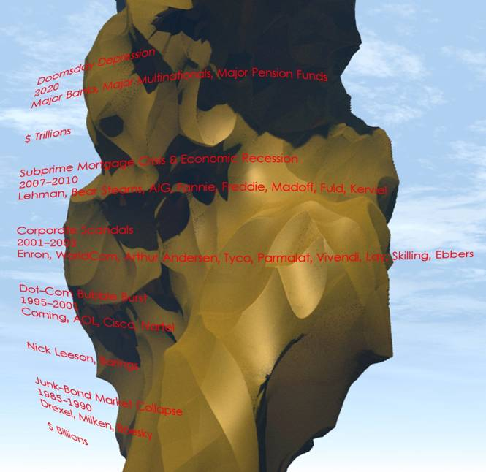

I wish Health, Well-being, Happiness, Longevity, Endurance, Self-fulfillment, Immunity to Depressionx2 & Corona, Ethics, Sustainability, Quality of Life...