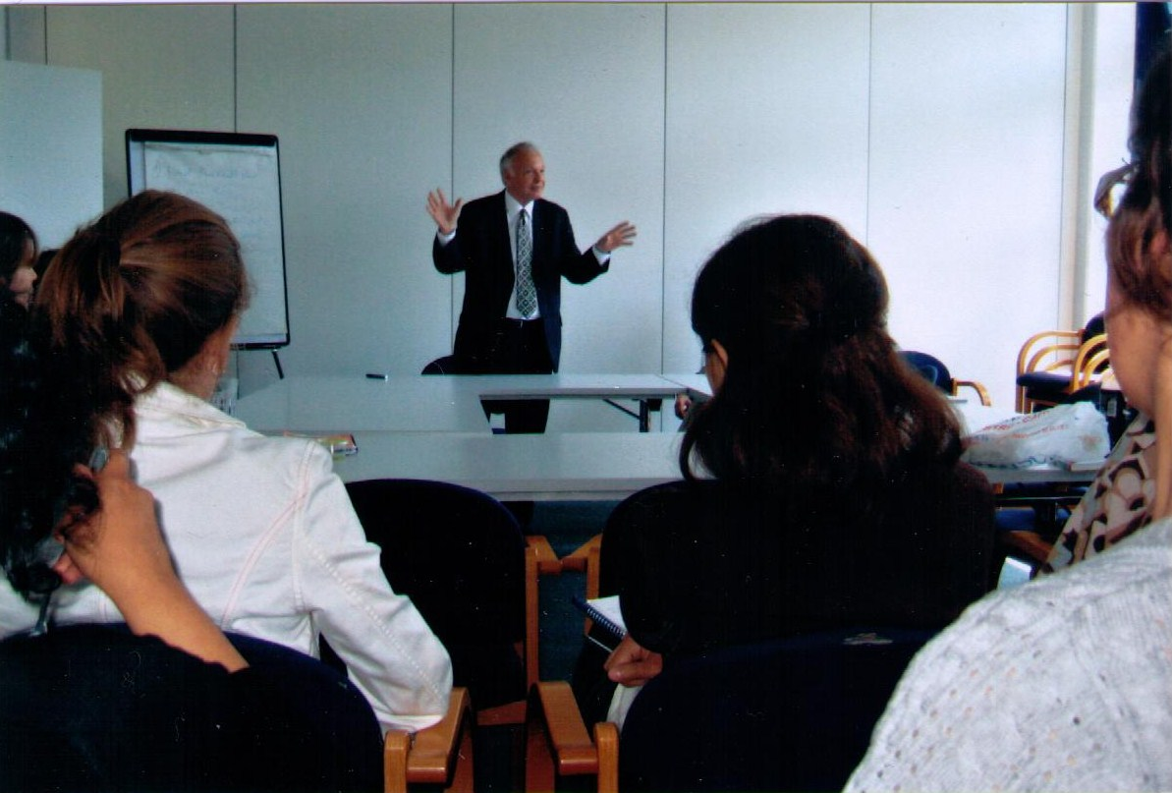

Dr. Jacques Cory, giving a lecture on June 4, 2010, as Keynote Speaker to the management of Transparency International - TI - at its headquarters in Berlin. Moderator: Dr. Francois Valerian, Head of Private Sector Programmes, with the participation of Dr. Miklos Marschall, Regional Director Europe and Central Asia, and other executives. The topic of the lecture was "Drawing Lessons from the Great Recession of 2007-2010", and it was divided in three parts along the main themes of Die Dreigroschenoper, The Threepenny Opera, by Bertolt Brecht. The response to the lecture was enthusiastic, with a vivid Q&A of more than half an hour.
The first part on transparency, common to TI and Cory's books, appears in the first act of the play: The ballad singer in the Prologue - the ballad of Mack the Knife: "Und Macheath, der hat ein Messer, Doch das Messer sieht man nicht", And Macheath has got a knife, but the knife is seen by no one. Analogies between Mack the Knife and the criminals of Wall Street who hid their schemes and thefts offshore and off balance sheet, and no one saw their knives.
The second part on the dilemma of profitability versus ethics, which according to Cory are compatible but according to many businessmen are an oxymoron. At the end of the second act Macheath and Jenny sing: "Erst kommt das Fressen, dann kommt die Moral", Voracity is the first thing, Morals follow on. We do not talk just about food, but voracity, excess, lavishness, salaries of hundreds of million dollars to the CEOs in parallel to layoffs of millions. When "Fressen" comes first, we never have time or resources for Ethics or Social Responsibility.
The third part of the lecture and of the play is at the end of the third act when Mack the Knife is "Gerettet, gerettet!", reprieved, reprieved, and instead of being hanged for all his crimes the Queen of England (or the US President, European Prime Ministers, and so on), gives Mack the castle of Marmarel, likewise a pension of ten thousand pounds, like the criminals of the Great Recession who were bailed out (they could indeed sing with Mack the Knife – bailed out, bailed out…), whose schemes cost the world more than ten trillion dollars, as they were too big to fail, transferring the losses from their companies to the governments, i.e. to us. After socializing the losses in 2008 , they privatized the profits in 2009, with salaries and bonuses of billions leading the world as the pied piper of Hamelin to a Doomsday Depression, with losses of hundreds of trillions, while no government would be able to bailout them or us!

