DOOMSDAY DEPRESSION IN 2020 – REALITY OR FANTASY? BY JACQUES CORY

The Washington Post published on November 4, 2019 an article with a title stating that: "Dow, S&P 500 and Nasdaq close at record highs, extending November’s record-setting start". And it continues: "U.S. stocks powered forward as investors reveled in strong economic data and global trade news. “There is no recession out there on the horizon,” Chris Rupkey, chief financial economist at MUFG Union Bank, wrote in a research note Monday. “The stock market can rejoice and continue to climb to new record highs.” “The market has risen in price nearly two out of every three Novembers and has recorded the greatest percentage of new all-time highs since World War II,” Sam Stovall of CFRA Research wrote in a research note Monday". … So, all is for the best in the best of all possible worlds!
Nevertheless, the year 2020 starts within a few days and we will soon learn if the prediction that I have made more than a decade ago will materialize or not. In 2009 I published a book in the US forecasting a Doomsday Depression in 2020 (see cover of book attached), as a result of the imperative necessity to change the basic rules of capitalism, especially in its neo liberal approach, which has caused crises – more and more frequent with higher and higher damages.
My prediction in that book and in other books, articles, courses, lectures and correspondence is based on a research after reading more than 150 books, 130 videos, thousands of articles and documents on those topics, and on my experience in international business & academics.
I forecasted that an Economic Whirl is likely to bring a meltdown of the world economy by 2020, if the causes of the crisis are not eradicated. When I made this prediction, I was the only one to do so, but for me it was obvious that as the lessons of the Great Recession were not learned it will take a decade for the Depression to occur. Today, prominent economists forecast at least a major recession in the near future. According to Fortune July 11, 2019:
"Experts are debating whether a recession is in the cards for 2020 (Fortune reported that 60% of economists think so), or if this expansion has room to run. But one thing is indisputable: several recession warning signals are already flashing." In an August 2019 survey of 226 economists conducted by the National Association for Business Economics, 38% of respondents said they believe the U.S. will enter its next recession in 2020, and 34% picked 2021; only 14% say it will occur after that. FORTUNE Analytics stated on October 11, 2019 that "Management Insiders Forecast a 2020 Recession". So, is it a Reality or a Fantasy?
Economic downturns are part of our life and they are not new, nor are the causes of the downturns new, at least not in the last couple of hundred years – greed, excessive leverage, lack of regulation, insufficient transparency, creative accounting and finance, and maximization of profits at all cost to the detriment of other stakeholders. What is new is the scope of the Economic Whirl, starting in billions twenty years ago, reaching trillions in 2008, and getting larger and larger at every stage, with the risk of endangering the world economy.
We could apply the standard medicines, such as lowering the interest rates, but they are now almost 0, pouring money into the economy, but we've reached the maximum with trillions, and, most of all, blaming Wall Street and the neo-liberals and pitying Main Street and the individuals who are the victims. We tend to forget that we are living in democracies and that no one forced us to invest in hedge funds, in speculative financial instruments, in subprime mortgages or to vote for the neo-liberal governments, so we could blame only ourselves that we voted for populist regimes and allow "democracies" which are in fact plutocracies.
We need to find unconventional ways to fight this whirl, to think outside the box, to adopt creative solutions, to establish a New Sustainable Society. I was in a unique position to devise original vehicles and pioneering methods to overcome the crisis, as I was one of the few businessmen who were also active in academics, writing books and articles with an international scope and educating thousands of businessmen and students who shared their experiences with me. I have forecasted the Enron and other corporate scandals in my pioneering book "Business Ethics: The Ethical Revolution of Minority Shareholders", published in March 2001 at Kluwer Boston (now Springer US), before they occurred in 2002.
Extraordinary as it seems, it was the first book ever written on ethics for minority shareholders and was based on my experience, research and theories on this subject. I found the rules of wrongdoing to minority shareholders that were validated a few months later at Enron. In my book "Selected Issues in Business Ethics and Social Responsibility", which was published by Magnes in July 2008 and written much earlier, I forecasted the Economic Recession and its causes and proposed efficient vehicles on how to overcome the crisis, none of them was implemented even today, as my books have unfortunately a very limited impact.
I knew that the storm was coming, I forecasted that after nothing was done following the Great Recession, there would come a Doomsday Depression by 2020, that this time will ruin the economies, some of the largest banks and pension funds and many major multinationals, and not even the US and EU governments could bail out the delinquents as they have done in 2008, as the scope of the losses would amount to tens to hundreds of trillions, far more than their economies. The panacea of lowering the interest rates would not work this time as they are for ten years now almost zero, an aberration, as money is a product with a price as all other commodities and reducing it to zero discourages savings and encourages irresponsible investments, haircuts, bubbles, excessive spending, high level of personal indebtedness, etc...
I saw the huge bubbles of real estate, the stock exchange, the huge levels by the hundreds of trillions of derivatives, none of them are effectively supervised, the stock exchanges are not supervised adequately either, there are no effective laws to regulate the economy, and worst of all – the criminals who caused the Great Recession were not punished but bailed out (except Madoff), and the Titanic was and is still sailing full speed ahead towards 2020.
I am not a prophet of wrath or a false prophet; I just had the time, academic and business background, and most of all the peace of mind to think about the situation, its causes and how to prevent the crisis. As I am not invested at all in the stock exchange, in real estate or in startups, I don’t have the temptation to rationalize why my investments are optimal.
Actually, I am the only one who admits that he has lost on the stock exchange, everybody else has only succeeded and made the best investments to the detriment of all the others, but who are the others? Probably not Warren Buffett, the best modern investor, who does not invest today the 128 billion dollars kept liquid in Berkshire Hathaway. He probably knows why and maybe is waiting for bargains/windfalls should a Depression occur, as there will be plenty…

What should we do? In the long run to implement the remedies that I devised in my books, but now it is too late to prevent the Depression. In the short run – today - I recommend my friends to divest from all investments in real estate, in the stock exchange – shares, government and industrial bonds, derivatives. The risk is losing a return on investment for 2020, but the prospect is to prevent a loss of up to 50%, or even 90%, as in the 1929 Depression. You could of course invest in derivatives betting on the scope and timing of the crisis, but it is too risky. Instead, I advise to keep your money in FDIC insured deposits in several banks. You can wait like Warren Buffett with plenty of liquid money for bargains/windfalls should the Depression occur in 2020, starting soon!

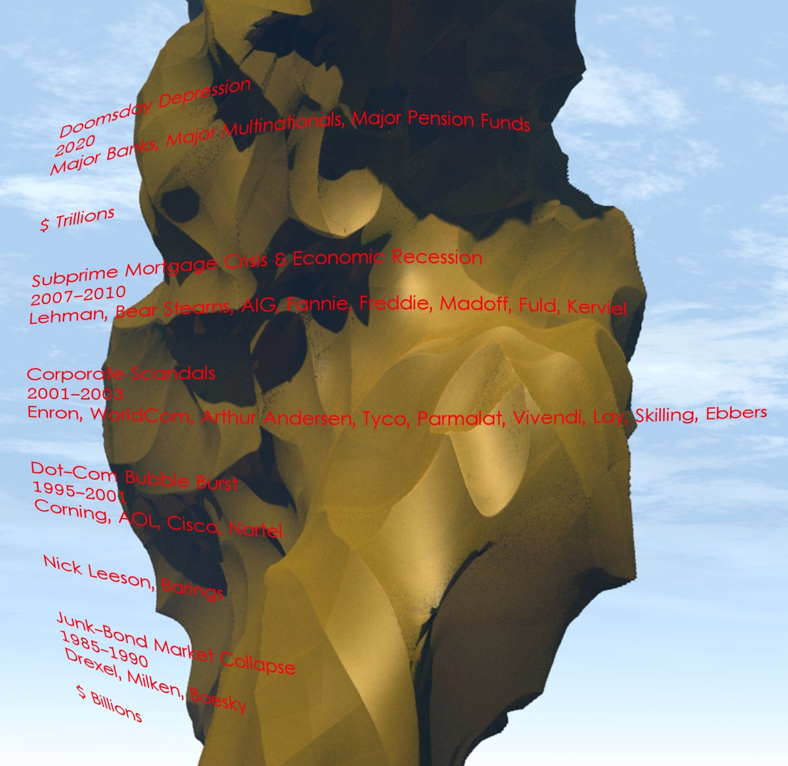

www.businessethicscory.com
link to the book

